EXPT NO: 8 | GENERATION OF SYNTHETIC IMAGES USING A GENERATIVE ADVERSARIAL NETWORK (GAN)
DATE: 02-11-2026

PRE-LAB QUESTIONS (PROVIDE BRIEF ANSWERS TO THE FOLLOWING QUESTIONS)

1. Discuss the roles of the Generator and Discriminator in a GAN.
The Generator creates fake data, such as images, from random noise. The Discriminator evaluates the input data and identifies whether it is real or fake. Both networks compete with each other to improve the quality of generated data.

2. Explain how a Generator produces synthetic images from random noise.
The Generator takes a random noise vector as input. It processes the noise through multiple neural network layers to generate an image. Through training, it learns to produce realistic images that resemble the original dataset.

3. Why is adversarial training important in a GAN?
Adversarial training allows the Generator and Discriminator to compete with each other. The Generator tries to create realistic fake images, while the Discriminator tries to detect them. This competition improves the Generator's ability to produce realistic and high-quality images.

4. Discuss the significance of the loss functions used to train the Generator and Discriminator.
Loss functions measure the performance of the Generator and Discriminator during training. The Generator's loss helps it create images that can fool the Discriminator. The Discriminator's loss helps it correctly distinguish between real and fake images. Together, these loss functions guide the GAN towards generating realistic data.

AIM
To implement and train a Generative Adversarial Network (GAN) to generate synthetic images by training a Generator and a Discriminator in an adversarial learning framework.

SOFTWARE REQUIREMENTS
- Python
- TensorFlow / Keras / PyTorch
- Google Colab
- GitHub
- NumPy
- Matplotlib
- Pandas
- Scikit-learn

OBJECTIVES
Students will be able to:
- Understand the architecture and working of Generative Adversarial Networks.
- Identify the functions of the Generator and Discriminator.
- Prepare image datasets for GAN training.
- Generate random noise vectors as inputs to the Generator.
- Build and train a simple GAN using a suitable dataset.
- Understand adversarial training and the associated loss functions.
- Generate synthetic images and visualize the results.
- Evaluate the quality and diversity of generated images through visual inspection.
- Document the experiment and manage the notebook using GitHub.

PROCEDURE
PART A: DATASET PREPARATION
Perform the following tasks:
- Load an image dataset, such as MNIST, and display sample images.
- Explore the image dimensions and pixel-value range.
- Normalize and reshape the images according to the GAN input requirements.
- Prepare batches of real images for training.
(CODE: CONATAINS STUDENT ROLL NOS
SCREENSHOT OF CODE
SCREENSHOT OF OUTPUT)

Code:

# ============================================
# PART A: DATASET PREPARATION
# Name: Mithunjai.E
# Roll Number: 24BAD071
# Experiment: Generative Adversarial Network
# ============================================

import numpy as np
import matplotlib.pyplot as plt
import pandas as pd
import tensorflow as tf

from tensorflow.keras.datasets import mnist

# Load MNIST dataset
(x_train, y_train), (x_test, y_test) = mnist.load_data()

# Display dataset information
print("Training data shape:", x_train.shape)
print("Testing data shape:", x_test.shape)
print("Data type:", x_train.dtype)
print("Image dimensions:", x_train.shape[1:])

# Display sample images
plt.figure(figsize=(10, 5))

for i in range(10):
plt.subplot(2, 5, i + 1)
plt.imshow(x_train[i], cmap='gray')
plt.title("Digit: {}".format(y_train[i]))
plt.axis('off')

plt.suptitle("Original MNIST Images")
plt.show()

# Normalize pixel values between -1 and 1
x_train = (x_train.astype('float32') - 127.5) / 127.5

# Reshape images
x_train = x_train.reshape(-1, 28, 28, 1)

# Display normalized information
print("\nAfter Normalization:")
print("Training data shape:", x_train.shape)
print("Minimum pixel value:", x_train.min())
print("Maximum pixel value:", x_train.max())

# Prepare dataset batches
BATCH_SIZE = 128

train_dataset = tf.data.Dataset.from_tensor_slices(x_train)

train_dataset = train_dataset.shuffle(60000).batch(BATCH_SIZE)

print("\nTotal training samples:", len(x_train))
print("Batch size:", BATCH_SIZE)

print("\nPART A COMPLETED SUCCESSFULLY")

Output:

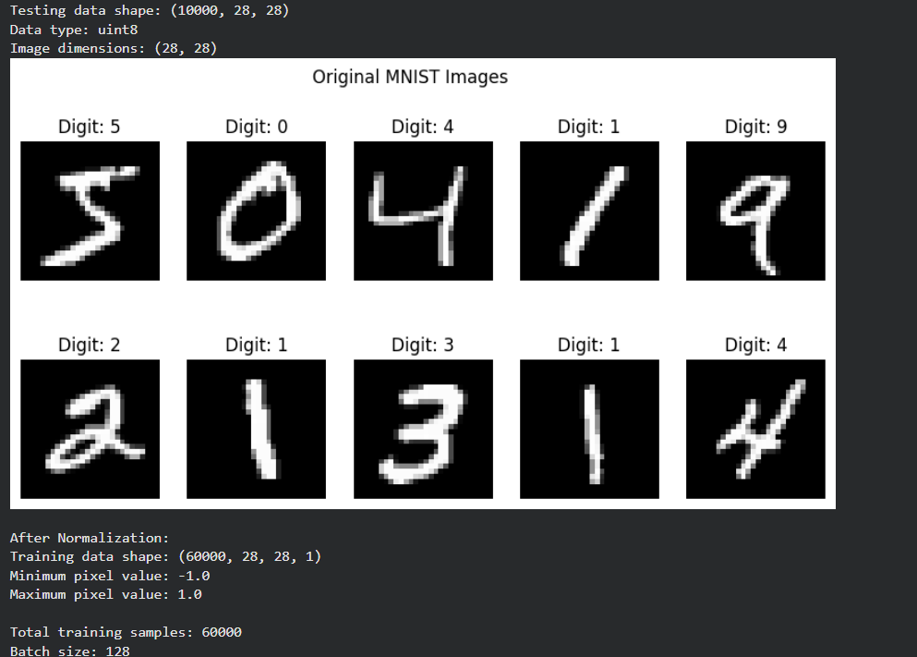

PART B: IMPLEMENTING THE THE GENERATOR AND DISCRIMINATOR
Perform the following tasks:
- Build a Generator model to create synthetic images from random noise vectors.
- Build a Discriminator model to classify images as real or generated.
- Select suitable layers, activation functions, optimizer, and loss function.
- Combine the Generator and Discriminator to construct the GAN.
- Display the model summaries.

(CODE: CONATAINS STUDENT ROLL NOS
SCREENSHOT OF CODE
SCREENSHOT OF OUTPUT)

Code:
# ============================================
# PART B: GENERATOR AND DISCRIMINATOR
# Name: Mithunjai.E
# Roll Number: 24BAD071
# ============================================

from tensorflow.keras import Sequential
from tensorflow.keras.layers import Dense, LeakyReLU
from tensorflow.keras.layers import Reshape, Flatten, Input

# Define noise dimension
NOISE_DIM = 100

# ============================================
# GENERATOR MODEL
# ============================================

generator = Sequential([
Input(shape=(NOISE_DIM,)),

Dense(256),
LeakyReLU(negative_slope=0.2),

Dense(512),
LeakyReLU(negative_slope=0.2),

Dense(1024),
LeakyReLU(negative_slope=0.2),

Dense(784, activation='tanh'),

Reshape((28, 28, 1))
], name="Generator")

# Display Generator summary
print("GENERATOR MODEL SUMMARY")
generator.summary()

# ============================================
# DISCRIMINATOR MODEL
# ============================================

discriminator = Sequential([
Input(shape=(28, 28, 1)),

Flatten(),

Dense(512),
LeakyReLU(negative_slope=0.2),

Dense(256),
LeakyReLU(negative_slope=0.2),

Dense(1, activation='sigmoid')
], name="Discriminator")

# Display Discriminator summary
print("\nDISCRIMINATOR MODEL SUMMARY")
discriminator.summary()

# ============================================
# COMPILE DISCRIMINATOR
# ============================================

discriminator.compile(
optimizer=tf.keras.optimizers.Adam(learning_rate=0.0002),
loss='binary_crossentropy',
metrics=['accuracy']
)

# ============================================
# COMBINE GENERATOR AND DISCRIMINATOR
# ============================================

discriminator.trainable = False

gan_input = Input(shape=(NOISE_DIM,))

generated_image = generator(gan_input)

gan_output = discriminator(generated_image)

gan = tf.keras.Model(
gan_input,
gan_output,
name="GAN"
)

gan.compile(
optimizer=tf.keras.optimizers.Adam(learning_rate=0.0002),
loss='binary_crossentropy'
)

# Display GAN summary
print("\nCOMPLETE GAN MODEL SUMMARY")
gan.summary()

print("\nPART B COMPLETED SUCCESSFULLY")
Output:
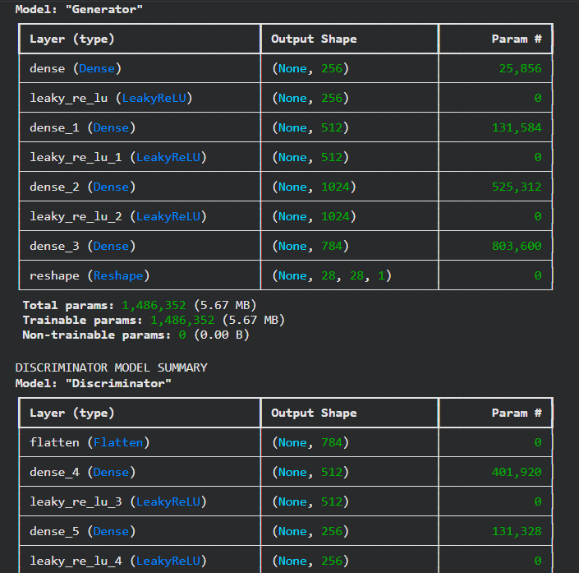
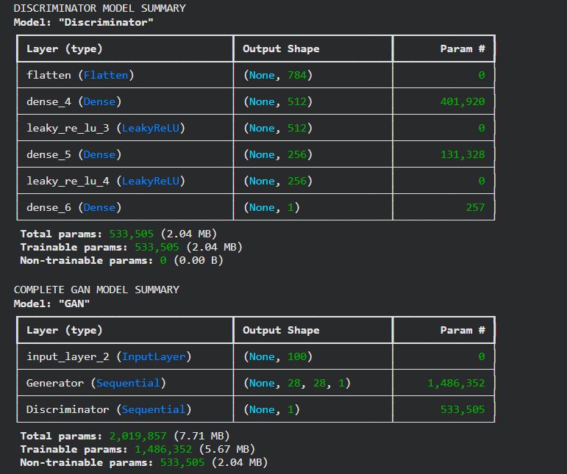

PART C: GAN TRAINING AND PERFORMANCE MONITORING

Perform the following tasks:
- Train the Discriminator using real and generated images.
- Train the Generator to produce realistic images.
- Alternate the training of both models for a suitable number of epochs.
- Record and plot Generator and Discriminator losses.
- Display sample generated images during training.

(CODE: CONATAINS STUDENT ROLL NOS
SCREENSHOT OF CODE
SCREENSHOT OF OUTPUT)

Code:
# ============================================
# PART C: GAN TRAINING AND EVALUATION
# Name: Mithunjai.E
# Roll Number: 24BAD071
# ============================================

# Define training parameters
EPOCHS = 50
BATCH_SIZE = 128
NOISE_DIM = 100

# Store losses
generator_losses = []
discriminator_losses = []

# Function to display generated images
def display_generated_images(epoch):

noise = tf.random.normal([10, NOISE_DIM])

generated_images = generator.predict(
noise,
verbose=0
)

generated_images = (generated_images + 1) / 2

plt.figure(figsize=(10, 4))

for i in range(10):
plt.subplot(2, 5, i + 1)

plt.imshow(
generated_images[i, :, :, 0],
cmap='gray'
)

plt.axis('off')

plt.suptitle("Generated Images - Epoch {}".format(epoch))
plt.show()

# ============================================
# GAN TRAINING LOOP
# ============================================

for epoch in range(EPOCHS):

g_loss_list = []
d_loss_list = []

for real_images in train_dataset:

batch_size = tf.shape(real_images)[0]

# Create random noise
noise = tf.random.normal(
[batch_size, NOISE_DIM]
)

# Generate fake images
fake_images = generator(noise, training=True)

# Labels for real and fake images
real_labels = tf.ones((batch_size, 1))
fake_labels = tf.zeros((batch_size, 1))

# Train Discriminator
discriminator.trainable = True

d_loss_real = discriminator.train_on_batch(
real_images,
real_labels
)

d_loss_fake = discriminator.train_on_batch(
fake_images,
fake_labels
)

d_loss = 0.5 * (
np.array(d_loss_real) +
np.array(d_loss_fake)
)

# Train Generator through combined GAN
discriminator.trainable = False

noise = tf.random.normal(
[batch_size, NOISE_DIM]
)

misleading_labels = tf.ones((batch_size, 1))

g_loss = gan.train_on_batch(
noise,
misleading_labels
)

d_loss_list.append(float(d_loss[0]))
g_loss_list.append(float(g_loss))

# Store average losses
avg_d_loss = np.mean(d_loss_list)
avg_g_loss = np.mean(g_loss_list)

discriminator_losses.append(avg_d_loss)
generator_losses.append(avg_g_loss)

print(
f"Epoch {epoch + 1}/{EPOCHS} | "
f"D Loss: {avg_d_loss:.4f} | "
f"G Loss: {avg_g_loss:.4f}"
)

# Display images every 10 epochs
if (epoch + 1) % 10 == 0:
display_generated_images(epoch + 1)

# ============================================
# PLOT GENERATOR AND DISCRIMINATOR LOSSES
# ============================================

plt.figure(figsize=(10, 5))

plt.plot(
generator_losses,
label='Generator Loss'
)

plt.plot(
discriminator_losses,
label='Discriminator Loss'
)

plt.title("GAN Training Loss")
plt.xlabel("Epochs")
plt.ylabel("Loss")

plt.legend()
plt.grid()
plt.show()

print("\nPART C COMPLETED SUCCESSFULLY")
Output:

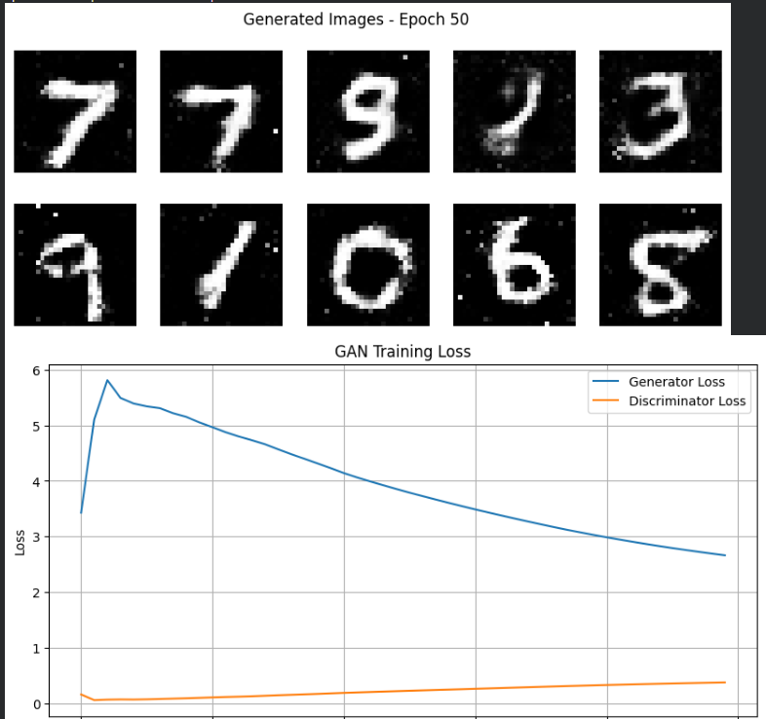
PART D: DIMENSIONALITY REDUCTION, FEATURE VISUALIZATION AND EXPERIMENT MANAGEMENT

Perform the following tasks:
- Provide new movie-review sentences as input to the trained LSTM model.
- Extract latent-space representations of test samples using the trained Encoder.
- Generate synthetic images using the trained Generator.
- Display and compare generated images with original dataset samples.
- Observe the quality, diversity, and recognizability of generated images.
- Document the experiment and upload the notebook to GitHub.

(CODE: CONATAINS STUDENT ROLL NOS
SCREENSHOT OF CODE
SCREENSHOT OF OUTPUT)

Code:
# ============================================
# PART D: IMAGE GENERATION AND VISUALIZATION
# Name: Mithunjai.E
# Roll Number: 24BAD071
# ============================================

# ============================================
# GENERATE SYNTHETIC IMAGES
# ============================================

# Generate 20 random noise vectors
noise = tf.random.normal([20, NOISE_DIM])

# Generate synthetic images
generated_images = generator.predict(
noise,
verbose=0
)

# Convert pixel values from -1 to 1 into 0 to 1
generated_images = (generated_images + 1) / 2

# Display generated images
plt.figure(figsize=(10, 8))

for i in range(20):

plt.subplot(4, 5, i + 1)

plt.imshow(
generated_images[i, :, :, 0],
cmap='gray'
)

plt.title("Fake Image")
plt.axis('off')

plt.suptitle("GAN Generated Synthetic Images")
plt.tight_layout()
plt.show()

# ============================================
# COMPARE REAL AND GENERATED IMAGES
# ============================================

plt.figure(figsize=(12, 5))

for i in range(10):

# Real image
plt.subplot(2, 10, i + 1)

plt.imshow(
(x_train[i, :, :, 0] + 1) / 2,
cmap='gray'
)

plt.title("Real")
plt.axis('off')

# Generated image
plt.subplot(2, 10, i + 11)

plt.imshow(
generated_images[i, :, :, 0],
cmap='gray'
)

plt.title("Generated")
plt.axis('off')

plt.suptitle("Real Images vs Generated Images")
plt.tight_layout()
plt.show()

# ============================================
# CHECK GENERATED IMAGE DIMENSIONS
# ============================================

print("Original Image Shape:", x_train[0].shape)

print(
"Generated Image Shape:",
generated_images[0].shape
)

print(
"Total Generated Images:",
len(generated_images)
)

# ============================================
# CALCULATE IMAGE DIVERSITY
# ============================================

generated_flat = generated_images.reshape(20, -1)

diversity = np.mean(
np.std(generated_flat, axis=0)
)

print("Generated Image Diversity Score:", diversity)

# ============================================
# SAVE GENERATED IMAGES
# ============================================

np.save(
"generated_images.npy",
generated_images
)

# Save Generator model
generator.save("gan_generator.keras")

# Save Discriminator model
discriminator.save("gan_discriminator.keras")

# ============================================
# SAVE TRAINING LOSSES
# ============================================

results = pd.DataFrame({
'Epoch': range(1, EPOCHS + 1),
'Generator Loss': generator_losses,
'Discriminator Loss': discriminator_losses
})

print("\nGAN TRAINING RESULTS")
print(results.tail())

results.to_csv(
"gan_training_results.csv",
index=False
)

print("\nSaved Files:")
print("1. gan_generator.keras")
print("2. gan_discriminator.keras")
print("3. generated_images.npy")
print("4. gan_training_results.csv")

print("\nPART D COMPLETED SUCCESSFULLY")
Output:
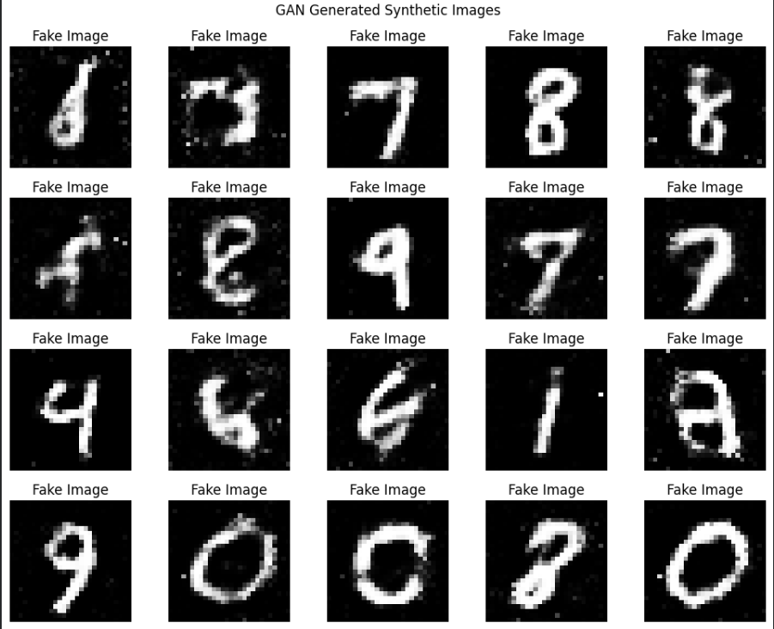
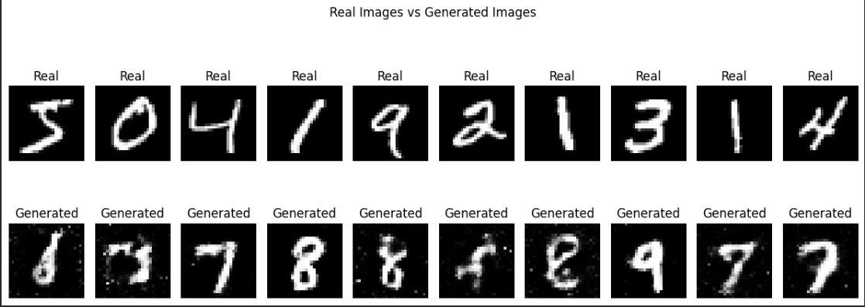
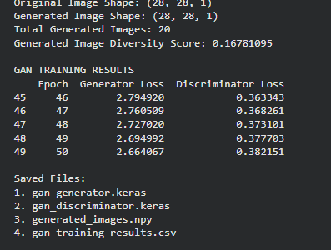

POST-LAB QUESTIONS (PROVIDE BRIEF ANSWERS TO THE FOLLOWING QUESTIONS)

1. Discuss how the quality of generated images changes as GAN training progresses. Explain why a GAN may generate repetitive or low-quality images.
Initially, GAN-generated images appear unclear and random. As training progresses, the Generator learns to produce more realistic images, improving their quality. Repetitive or low-quality images may occur due to mode collapse, poor training balance, or insufficient training data.

2. Differentiate between the Generator loss and the Discriminator loss.
Generator loss measures how well the Generator fools the Discriminator by producing realistic images. Discriminator loss measures how accurately the Discriminator identifies real and fake images. Both losses help improve the performance of the GAN during adversarial training.

3. Discuss two real-world applications of GANs apart from handwritten digit generation.
- Image Enhancement: GANs improve image resolution, remove noise, and restore damaged photographs.
- Image Generation: GANs generate realistic human faces, artificial images, and visual content for entertainment, gaming, and design.

ASSESSMENT
Description | Max Marks | Marks Awarded
Pre Lab Exercise | 5
In Lab Exercise | 10
Post Lab Exercise | 5
Viva | 10
Total | 30
Faculty Signature

